Fig.1 Flowchart

Fig.2 Web page -2

Fig.3 No db and No collection

Fig.4 New DB and Collection (With duplication of documents)

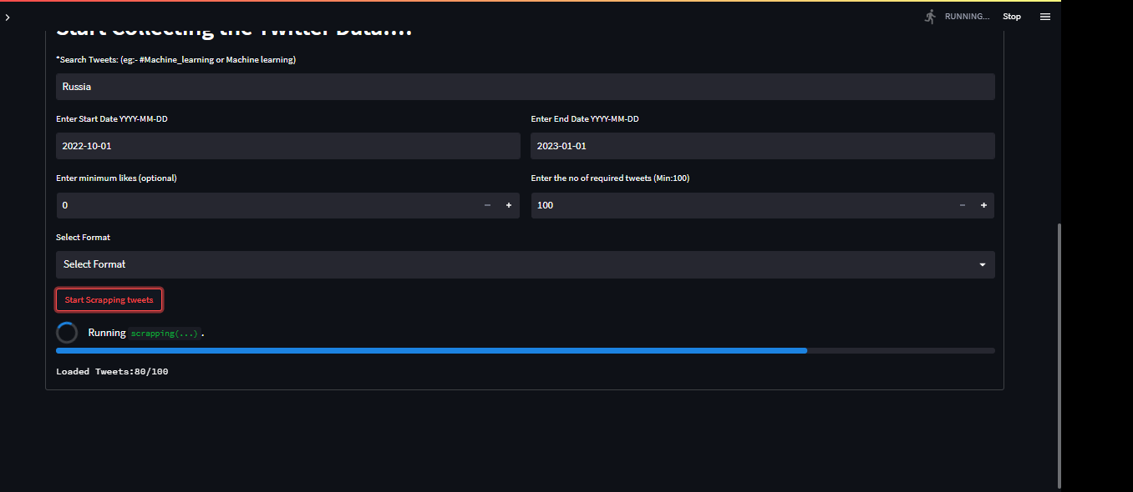fig.5 scrapping Tweets with sample input



fig.6 Progress bar

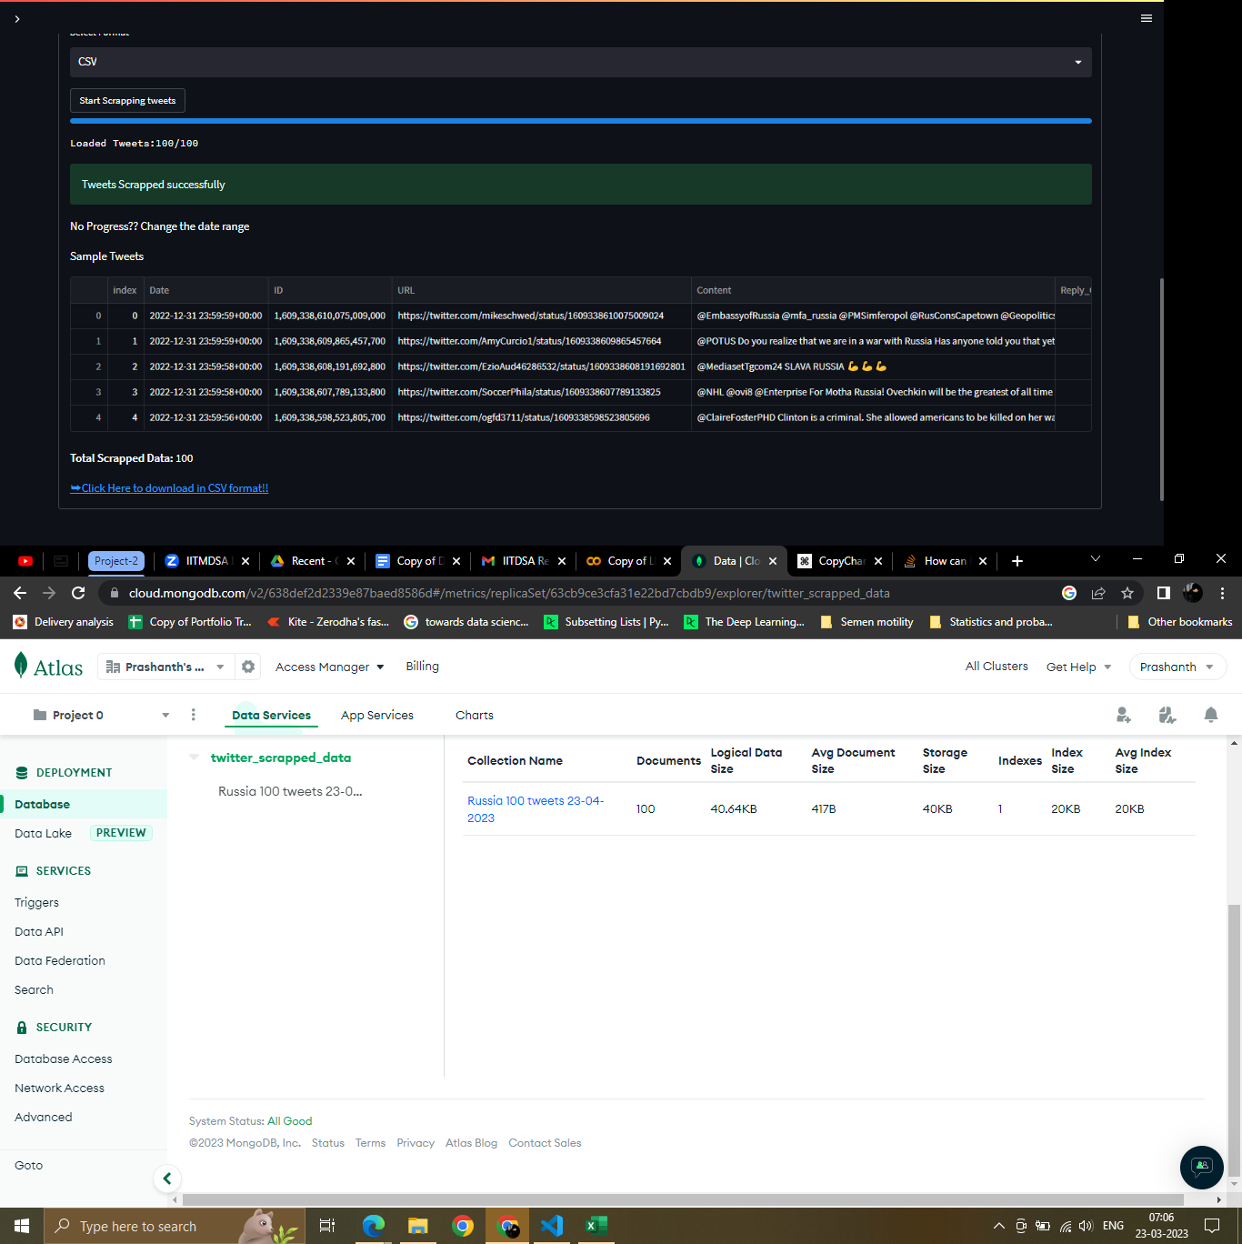

Fig.7 Sample scrapped tweets

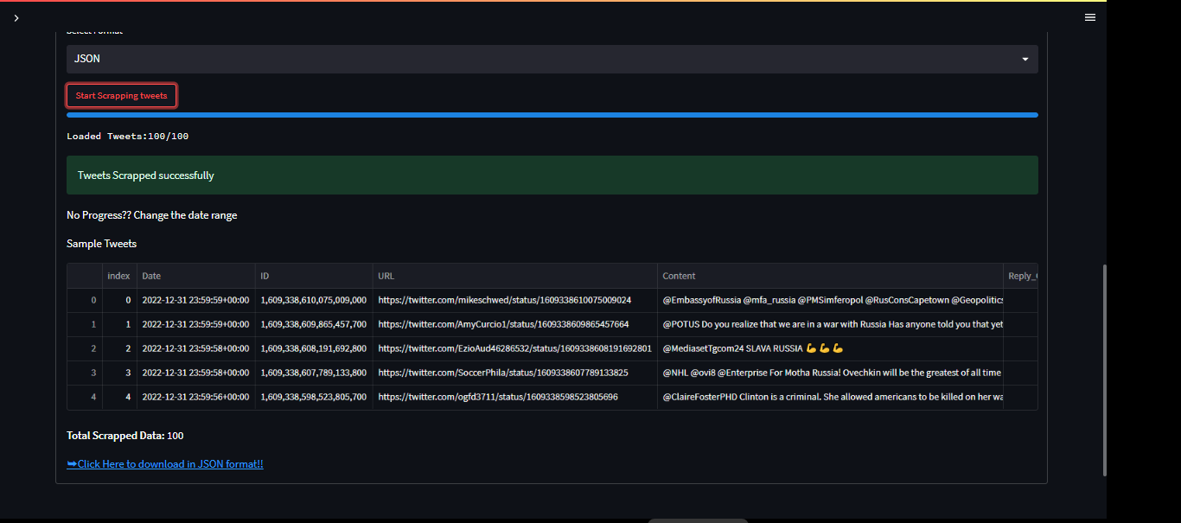

Fig.8 Link to download.